**FACE RECOGNIZER TESTING REPORT**

# Face Detection Testing

1. The result after detecting an image 100 times is the same.
2. Below is the report about performance, accuraccy of each HaarXML files. (Each HaarXML file is created by running Haar Training).

The bold text are the best result among four XML files.

|  |  |  |  |  |
| --- | --- | --- | --- | --- |
| **HaarXML Files** | **Alt** | **Alt2** | **Alt_Tree** | **Default** |
| Time to run 100 detections.  Image resolution:  750 x 500.  (This is the resolution of facebook image.) | 108s  Average Time: 1.08s | 86s  Average Time: 0.86s | **55s**  **Average Time: 0.55s** | 82s  Average Time: 0.82s |
| Time to run 100 detections.  Image resolution :  2200 x 1500.  (This is the resolution of camera image) | 1071s  Average Time: 10.7 s | 901s  Average Time: 9s | **561s**  **Average Time: 5.6s** | 724s  Average Time: 7.24s |
| Time to run 100 detections. Image resolution :  2200 x 1500.  The image is resized to 1100 x 750 px before detecting. | 235.5s  Average Time: 2.35s | 181.7s  Average Time: 1.82s | **116.5s**  **Average Time: 1.16s** | 137.5s  Average Time: 1.38s |
| Sample Image : 100 images, contains 222 faces.   * Accuracy (Detect all faces in images). * Missing Hit (Can’t detect enough face in image) * Over Hit ( Detect more face than in image) | **Accuracy: 70%**  Missing: 11%  Over: 19%  Face detected: 233/222 faces  **Real face detected:**  **206/222 faces.**  **Real face detect ratio:**  **92.8%** | Accuracy: 62%  Missing: 9%  Over: 29%  Face detected: 248/222 faces  Real face detected:  204/222 faces.  Real face detect ratio: 91.9% | Accuracy: 67%  Missing: 30%  **Over: 3%**  Face detected:  179/222 faces  Real face detected:  173/222 faces.  Real face detect ratio: 77.9% | Accuracy: 38%  **Missing: 7%**  Over: 55%  Face detected: 324/222 faces  Real face detected:  206/222 faces.  Real face detect ratio:  92.8% |
| Sample Test: 140 images, number of face unknow.  Testing the ratio of real face detection | Detected: 450 faces.  **Real face: 401 faces.**  Error: 49 faces  Ratio: 89.1% | Detected: 477 faces.  Real face: 401 faces.  Error: 76 faces  Ratio: 84.07% | Detected: 338 faces.  Real face: 326 faces.  **Error: 12 faces**  **Ratio: 99.4%** | Detected: 645 faces.  Real face: 399 faces.  Error: 246 faces  Ratio: 61.86% |
| Conclusion | Worst performance.  The number of real face detected is biggest.  -> This HaarXML should be used when admin upload image for adding data. The error doesn’t matter much here. | So-so performance.  The same number of real face detected as alt1 | Best performance.  Best real face detection ratio.  -> This HaarXML should be used when instructor upload image for checking attendance. | So-so performance.  Lowest accuracy.  Lowest real face detection ratio. |

# Face Recognition Testing

For face recognition, we will test with three difference face recognizers: Eigen Face Recognizer, Fisher Face Recognizer, LPBH Face Recognizer. Each Recognizer is setup with 3 diffent threehold.

|  |  |  |  |
| --- | --- | --- | --- |
| **Face Recognizer** | **Eigen Face Recognizer** | **Fisher Face Recognizer** | **LPBH Face Recognizer** |
| Training Data with 600 images, 30 ID.  Recognize 200 faces | Image Load Time: 9 ~ 13s.  Training Time for 9 Recognizer: 113s.  Average Training Time: 12.56s | | |
| Time: 0.37s | **Time: 0.12s** | Time: 9s |
| Training Data with 250 image, 25 ID.  Recognize 200 faces | Image Load Time: 3 ~ 5s.  Training Time for 9 Recognizer: 11s.  Average Training Time: 1.22s | | |
| Time: 0.36s | **Time: 0.08s** | Time: 4.1s |

About accuracy report:

- Training Data: 64 faces of 6 people: Bao, Hoang, Dung, Hoa, Minh, Sen. (Each person with 9~11 faces).

- Test Data: 78 faces of those 6 people. 16 unknown faces.

We begin with the training data of 4 images for each person, then 6, 8, 10 images.

The graph compare the accuracy of each algorithm:

For detail report, check the txt files.

# Face Recognition Testing In Real World

The things we are going to test is:

* Minimum, maximum number required to recognize all student in class.
* The average number of student recognized each picture

## First Test

The first time, we check a roll call with 20 students. In classroom, there are 13/20 students available.

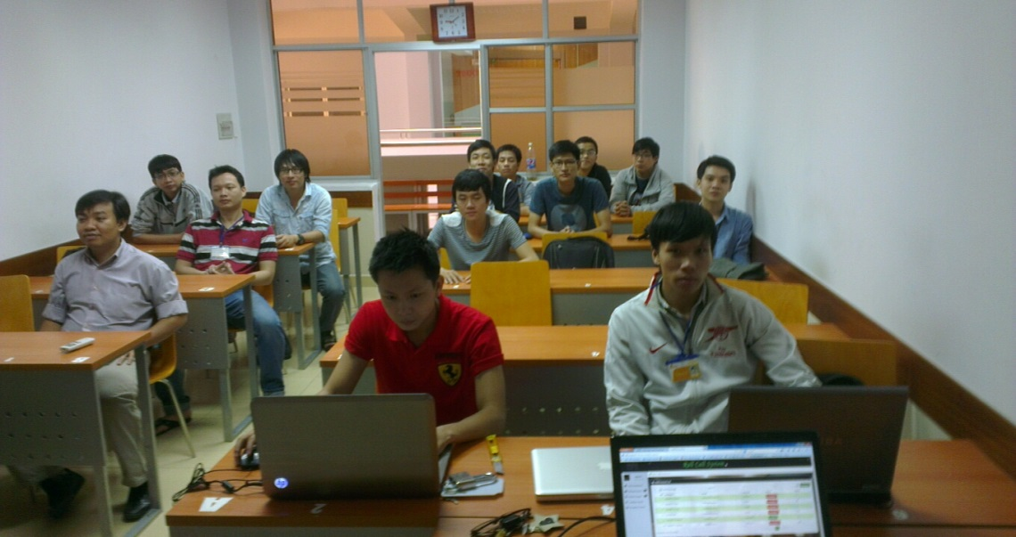

We took total 53 images for testing.

### Check number of images required

We run the test 10000 times. Each time, we select random images, use those image for recognizing until the number of detected students is larger than 13.

**Testing Result:**

**Minimum Images Required:** 2

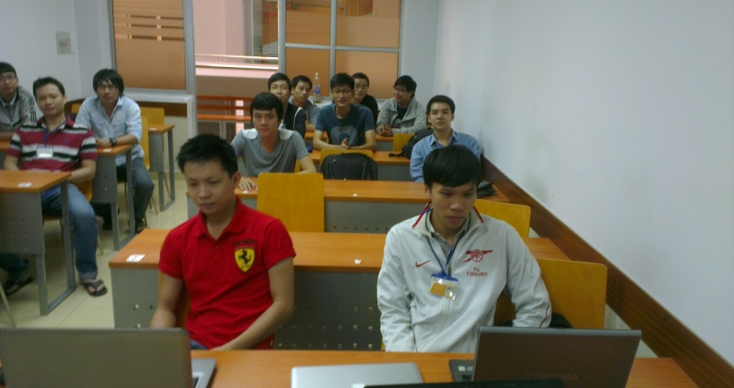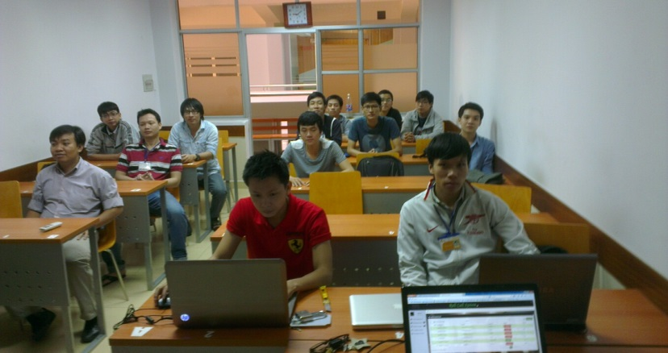

**Maximum Images Required:** 9

**Average Images Required**: 3.655

### Avarage number of student recognized by picture

We increase the number of images using for recognizing from 1 to 10. Each times we choose randoms images from taken images, then run the test 1000 times, find the avarage number of students recognized

## Second Test

The first time, we check a roll call with 24 students. In classroom, there are 13/24 students available (Another students from first test).

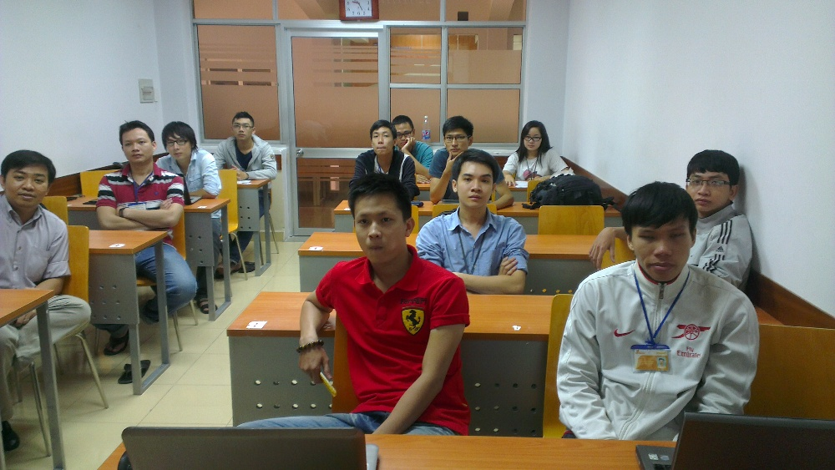

We took total 11 images for testing.

### Check number of images required

**Minimum Images Required:** 2

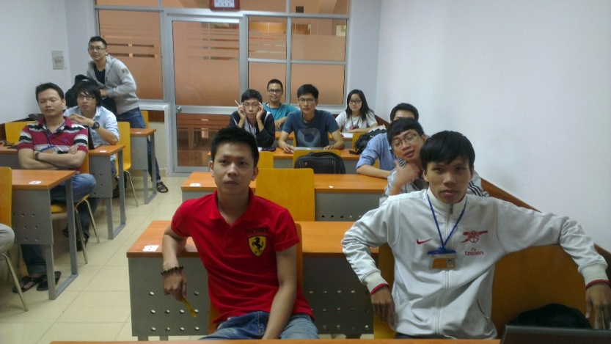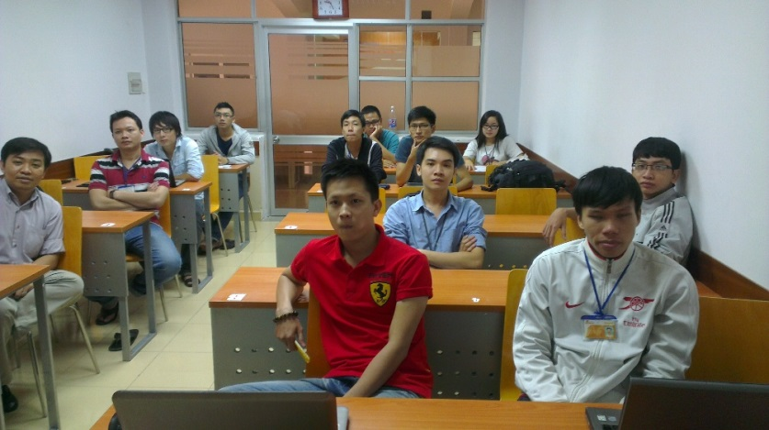

**Maximum Images Required: 7**

**Average Images Required: 3.5704**

### Avarage number of student recognized by picture

**Conclusion:** The recommend number of images to recognize all student is 4-5 pictures.